**QUESTION 1 TEST CASE RESULTS (VS Code Terminal)**

**HeapSortTest.java**

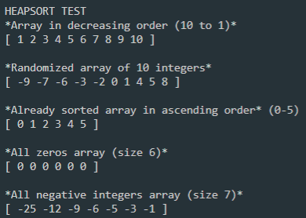

**QUESTION 2 TEST CASE RESULTS (VS Code Terminal**

**GraphTest.java**

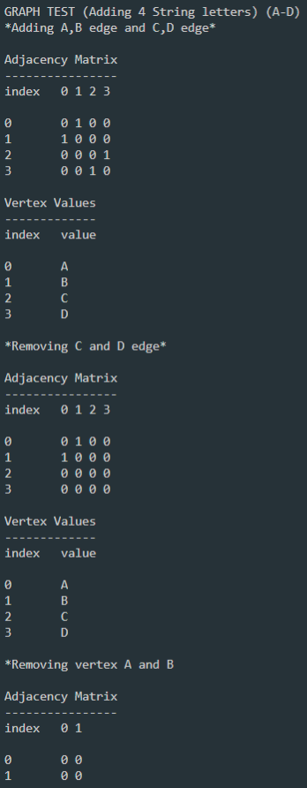

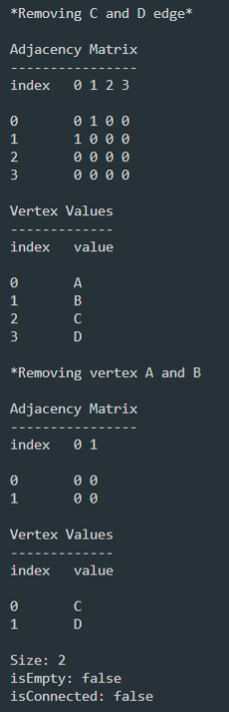

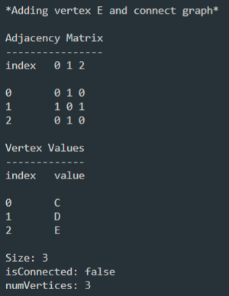

**QUESTION 3 TEST CASE RESULTS (VS Code Terminal)**

